# GH Hackathon

Hello, and welcome to the first ever GH Hackathon, well not really a hackathon but an in-circle event to improve in some way or the other our tech skills. The major aim of this is to have fun as that’s what *Gamers Hub™* is all about, having fun with friends.

Just do your best, it’s really not that deep.  
  
Need music while working on it? I recommend Jax’s Spotify playlist: <https://open.spotify.com/playlist/5zr3stmAfJJU8iLqIDQG0r?si=a0e4fd4ab7e642fb>  
  
You’re welcome!

# Hackathon Theme: Winter Games

## EVENT 1:

The first event you are competing in is the Biathlon. It's an event that requires both endurance and precision under stress.

The biathlon event consists of sections of skiing, interspersed with sections of shooting. In each shooting section, you fire 5 shots at 5 targets. You must take a lap on the penalty track for every shot missed before starting to race towards the next section.

You are given the track, which is an array of positive integers, representing the length of each section in meters. There are always at least 2 sections. You are also given the length of the penalty track. It's the same for all shooting sections.

You have a list of your competitors to beat. Your team has compiled some statistics about them, like speed and accuracy. It should help you identify which of them you need to watch out for during the event.

You are given the list of competitors that you have data for as an array of comma-separated values. It has 3 parts, the number on the competitor ski-suit (a unique positive integer), their average speed in m/s (a positive decimal) and their shooting accuracy (a positive integer, at least 2).

For our purposes, shooting accuracy means that that competitor will always miss every nth shot. So if it's 3, that competitor will always hit twice and miss once, in that order.

You trust your team to give you sensible data, in the right format.

Calculate which competitors would win the event. Return their suit numbers in an array of integers. If there is a tie, order them in increasing order by suit number.

"1,7.2,5",

"2,6.8,8"

* After the first skiing section, competitor 1 is in the lead.
* In the first shooting section, competitor 1 misses 1 shot, while competitor 2 hits all 5. As a result, competitor 2 overtakes competitor 1.
* After the second skiing section, competitor 2 remains in the lead.
* In the second shooting section, both competitors miss 1 shot and take a penalty lap, so the standings don't change.
* During the third skiing section, competitor 1 overtakes competitor 2.
* During the third shooting section, competitor 1 misses their last shot again, and during their penalty lap competitor 2 is in the lead again, having not missed a single shot this time.
* In the fourth skiing section, competitor 2 retains their lead but competitor 1 is closing the distance.
* In the fourth shooting section both competitors miss 1, and during the penalty lap competitor 1 gets closer again to competitor 2.
* In the final skiing section competitor, 1 gets very close, but in the end competitor 2 is awarded the gold medal.

EVENT 2:  
This second event is specially created for those on the Creative/ web side of gamers’ hub.   
Your task is quite simple. From the time you are reading this till exactly a week into the future, you are required to recreate the following specified sections on the Olympics Biathlon page [**HERE**](https://olympics.com/en/sports/biathlon/#discipline-history-of)**:**Header, Navbar, Filler text


**-------------------- Header, Navbar, Proflie picture frame, Search bar-------------------**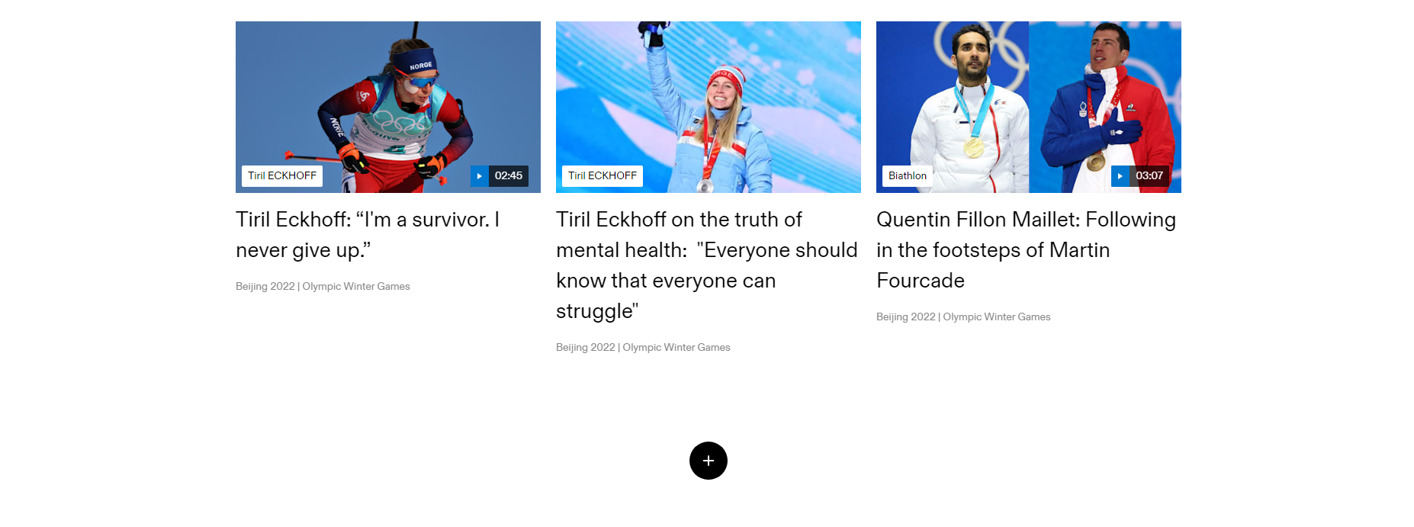

**------------------------------- Blog Titles section boxes with pictures -----------------------------------**

------------------ **Shorter but just as cool footer with Icons and links ---------------------**

The page should be quite simple because you don’t have to do exactly everything. You also are not limited to this colour theme on your page. You have complete artistic freedom of your website.  
Please take into consideration responsiveness of your page(i.e your links working, your buttons being able to do what they want after clicking and finally how they work across devices). Responsiveness is not compulsory for any links in your navbar or links in your footer but are compulsory for icons in your footer  
  
The compulsory requirements for this assessment are :  
- How accurately you can recreate the site  
- Fonts, color theme choice and cntent  
- All media must be from the “Playman Winter Games” franchise

Everyone has an option to do one or both events. You are advised to stick to doing only one because everyone has a week from now to do either or both.

Competitors x Languages:  
  
Milan aka CJ aka Cole Tutorz – JavaScript  
Mubby – HTML/CSS  
Majin’s quest boy Esenwa - Python   
Epra – HTML/CSS  
Tosin – Java I guess?  
Jax – C# merchant  
Vikenn – Pseudocode/ Logic